  City of Ontario
  President of Council
  Eddie Gallo
  567-241-3016
  Council at Large
  Anderson Roll
  567-333-0387
  Council at Large
  Rick Pauley
  419-545-3698
  Council at Large
  Brennen Finfgeld
  567-333-1456
  First Ward Councilman
  Nathan Sunderland
  419-545-1848
  Second Ward Councilwoman
  Rose Feagin
  419-543-1970
  Third Ward Councilwoman
  Sherry Branham-Fonner
  419-566-9527
  Fourth Ward Councilman
  Jason Bilyj
  419-405-5004
  City of Ontario
  555 Stumbo Rd
  Ontario, Ohio 44906
  CITY
  OF ONTARIO
  
  555 STUMBO RD. ONTARIO, OH 44906
  419-529-3818
  www.ontarioohio.org
www.facebook.com/ontarioohio
  Chief Tommy Hill  Police Department 419-529-2115  Springfield TWP Fire / EMS  Station #1 419-529-4416  Station #2 419-529-5512  Richland Co. Sheriff’s Dept. 419-524-2412    Recreation Director Kenn Spencer  419-566-8072  info@oysports.com  recreationdept@ontarioohio.org |  |  | Ontario Civil Service Commission  (419) 529-3818  Jim Boyer Michael Howard  Herb Homan  Ohio Planning Commission  (419) 529-3818  Jill Knight Diane Wolfe  Hank Webb  Ontario Board of Health  (419) 529-3818  Chelsia DeRenard Cathy Sapp  Ontario Senior Center  419-529-2954  Ontario Public Library  419-529-4912  Ontario Board of Education  419-747-4311  Ontario District 5 Area Agency on Aging  419-524-4144  Richland County Board of Elections  419-774-5530  Ontario Community Room  Rent on City Website only  Marshall Park Pavilion  Rent on City Website only
  SP
  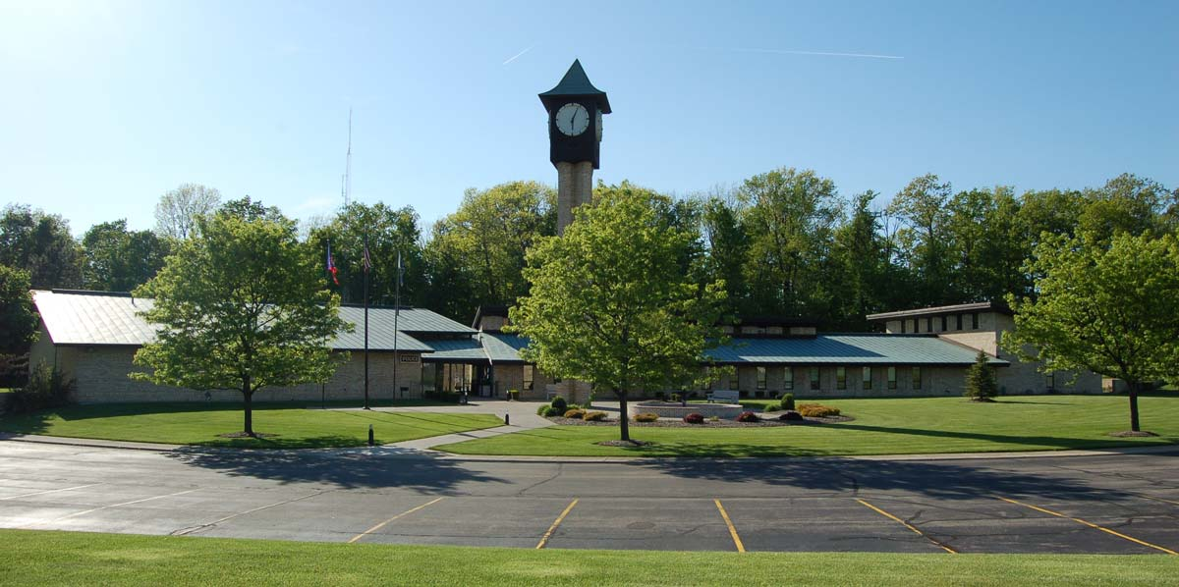
  Make It Yours
  To get started right away, just tap any placeholder text (such as this) and start typing to replace it with your own.
  Want to insert a picture from your files or add a shape, text box, or table? You got it! On the Insert tab of the ribbon, just tap the option you need.
  Find even more easy-to-use tools on the Insert tab, such as to add a hyperlink or insert a comment.
  Customize in Almost No Time
  Think a document that looks this good has to be difficult to format? Think again! To easily apply any text formatting you see in this document with just a tap, on the Home tab of the ribbon, check out Styles.
  “Your company is the greatest. I can’t imagine anyone living without you.”
  - Very smart customer
  Ontario Municipal Building
  Mayor – Josh Bradley 419-529-3818
  Service Safety Director–Michael Morton 419-529-2495
  Law Director – Andrew Medwid 419-529-3776
  Auditor – Logan Hull 419-529-2397
  Deputy Auditor – Brian Musille 419-529-2269
  Treasurer – Shannon Lorentz-Wiese 419-529-3925
  Clerk of Council – Cathy VanAuker 419-529-6714
  Clerk of Courts – Janet Yeager 419-529-3723
  Administrative Assist. – Barbara Reeder 419-529-3818
  Water Clerk – Darci Thompson 419-529-4607
  Income Tax Clerk – Sallie Neal 419-529-3045
  Income Tax Clerk – Kristy Frost 419-529-3227
  Income Tax Clerk – Ashley Sutter 419-529-2170
  Ontario Service Building
  Sewer Supervisor – Jay Hriesik 419-529-6341
  Street Supervisor – Jody Orewiler 419-529-3815 Park Supervisor – Cory Cardwell 419-529-2588
  Cemetery Director – Keith Clark 419-529-2537
  Zoning Inspector – Benji Hall 419-529-2530
  Ontario Water Treatment Plant
  Water Supervisor – Tim Rietschlin 419-529-3846

